Assignment 3 – Power Query Editor

1. Spited City Column

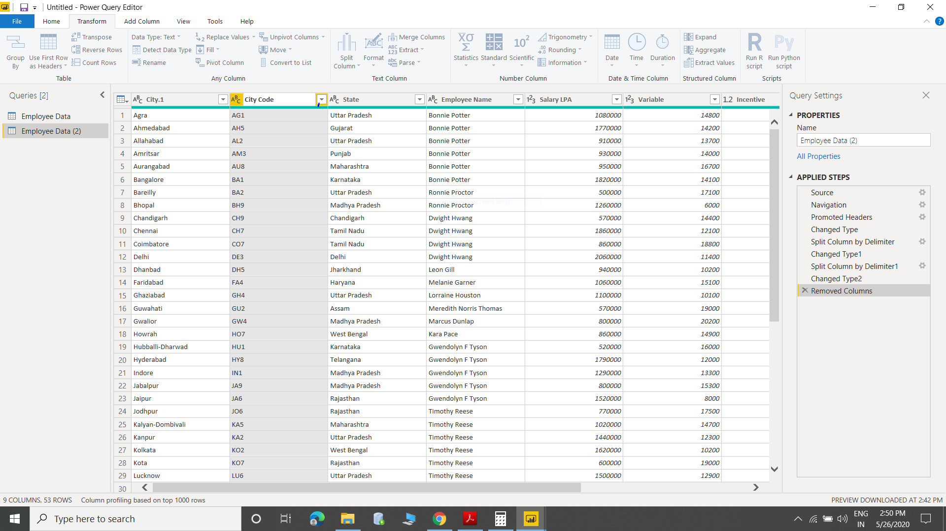

1. Extracted the first name of employee.

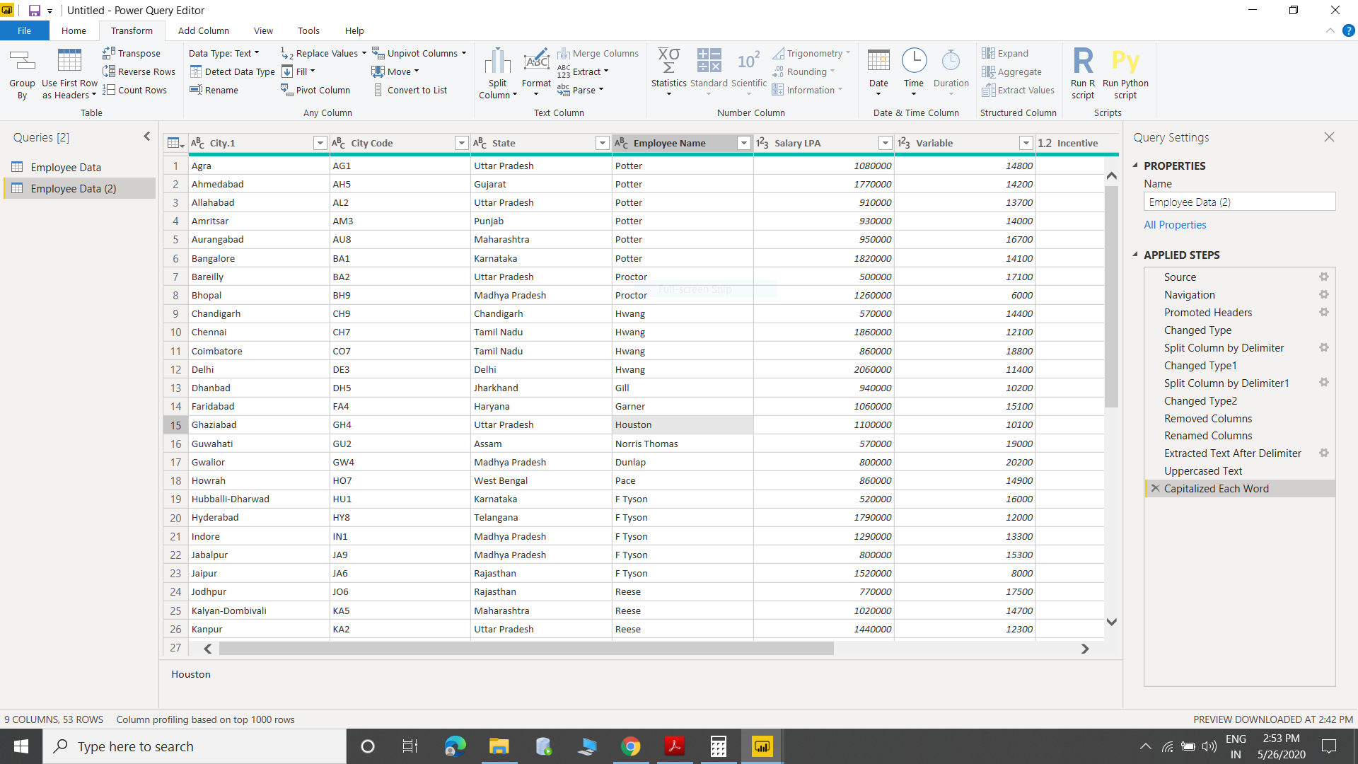

1. Extracted joining data column

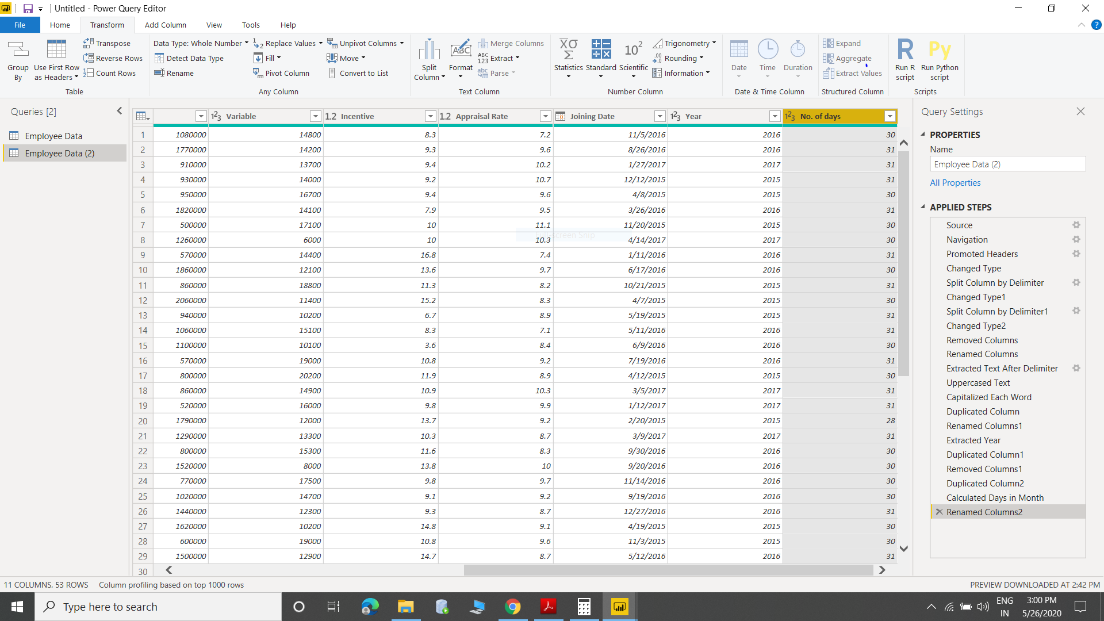

1. Employee salary data by state wise (Highlighted lowest payout state-Chandigarh)

